ECE 202 Lab 1: AC SIGNALS AND PHASORS

|  |  |
| --- | --- |
| Arciga, Melinda *University of Tennessee, Knoxville* Knoxville, Knox marciga@vols.utk.edu | Barnes, Stanley *Univeristy of Tennessee, Knoxville* Knoxville, Knox wbarne12@vols.utk.edu |

***Abstract–*This laboratory experiment aims to deepen our understanding of voltage and power dynamics in AC circuits through hands-on analysis and theoretical study. Focusing on how variable load resistances affect power transfer, the lab examines the interaction between resistive and reactive components under a constant AC source. Key objectives include studying the effects of load impedance changes and achieving optimal power transfer through reactive power compensation.**

1. INTRODUCTION

AC circuits are crucial for efficient energy distribution, and their components—resistors, capacitors, and inductors—play a significant role in determining overall circuit behavior. By modifying the resistive load and adjusting a compensation capacitor, we explore maximum power transfer and reactive power nullification, fundamental for enhancing circuit efficiency.

This report will cover the experiment's methodology, circuit setup, observed waveforms, and calculations, supplemented by simulation comparisons to align experimental findings with theoretical predictions.

1. PROCEDURE

Equipment:

* Digital Multimeter
* Digilent Analog Discovery Studio
* Various resistors, inductors, and capacitors as specified
* Signal Generator platform (Digilent WaveForms)
* LTspice

*A. Activity 1: Signals and Phasors*



Fig 1. The circuit used for Activity 1. The resistor represents an arbitrary load Z. The values for Z are listed in Table 1.

1. ACTIVITY 1 PARAMETERS

|  |  |
| --- | --- |
| ***Parameter*** | ***Value*** |
| Z | $$R$$ |
| Z | $$jωL$$ |
| Z | $$1/jωC_{1}$$ |
| Z | $$R+jωL$$ |
| Z | $$R+1/jωC_{1}$$ |

We initiated the experiment by setting up the circuit on a breadboard, according to Fig 1, to investigate the impact of different impedance configurations ($R, jωL, 1/jωC, R+jωL, R+1/jωC$) on AC circuit behavior. Using a combination of resistors, inductors, and capacitors, we meticulously assembled each impedance configuration starting with the simplest resistive load (R = 600 Ω). After securing and verifying the connection of each component, we utilized an oscilloscope to capture the time-domain waveforms of the current and voltage for the resistive setup.

Subsequently, we replaced the resistor with a 100 mH inductor (jωL) to observe the effects of inductive impedance, closely monitoring the phase shift and amplitude changes in the waveforms. Following the inductive measurements, the setup was altered to include a 120 nF capacitor (1/jωC), which allowed us to examine the capacitive effects on the circuit. For complex impedances (R+jωL and R+1/jωC), components were combined in series, and measurements were carefully repeated. During each change, the digital multimeter was used alongside the oscilloscope to ensure the accuracy of the RMS values, enhancing our understanding of phasor relationships and power distribution in AC circuits. To complement these measurements, we also created equivalent circuits in LTspice for each configuration. This simulation helped verify our theoretical calculations and provided a visual representation of the expected waveforms and phasor diagrams.

*B. Activity 2: Impedance Matching*



Fig 2. The circuit used for Activity 2. R, L, and C1 are all defined in Table 2. Rload and Ccomp are part of the impedance matching.

1. ACTIVITY 1 AND 2 PARAMETERS

|  |  |
| --- | --- |
| ***Parameter*** | ***Value*** |
| $$R$$ | $$600 Ω$$ |
| $$L$$ | $$100 mH$$ |
| $$C_{1}$$ | $$120 nF$$ |
| $$C_{comp}$$ | To be determined |
| $$R_{load}$$ | $$0-2000 Ω$$ |

For the second activity, we focused on the dynamics of power transfer in response to variable load resistances and the application of reactive power compensation. Starting with the assembly of the circuit as outlined in the schematic, we integrated a potentiometer to adjust Rload from 0 to 2kΩ and began our experiments by measuring the uncompensated power transfer. Simultaneously, we modeled this setup in LTspice, adjusting the load resistance in the simulation to parallel each physical adjustment and verify the impact on power transfer.

After establishing a baseline, we introduced a variable capacitor (Ccomp) to the circuit for reactive power compensation. For each adjustment of Rload, we meticulously tuned Ccomp achieve Qload = 0 at 1kHz, both experimentally and in the LTspice simulation. This dual approach of practical experimentation complemented by simulation provided a robust method to precisely identify conditions for maximum power transfer and validate the effectiveness of the compensatory adjustments. Throughout these tests, the LTspice simulations were instrumental in predicting the outcomes and ensuring that our setups were correctly implemented to achieve the desired reactive power compensation.

1. CALCULATIONS

*A: Activity 1: Given a circuit with specified parameters, find the voltage and current phasors as well as the phasor diagram and power triangle*

1. *Calculations for $Z=R$*



$$V_{max}=2 \left[V\right],{ V}_{rms}=1.414 \left[V\right], \overline{ V}=1.414∠0° [V]$$

$$Z=R=600 Ω$$

$$\overline{I}=\frac{\overline{V}}{Z}=\boxed{2.36∠0° [mA]}$$

$$i\left(t\right)=\boxed{2.36\sqrt{2}*\cos\left(2000πt\right)[mA]}$$

$$P=\boxed{3.34 [mW]}$$

$$Q=\boxed{0 [VAR] }$$

$$S=P=\boxed{3.34 [mVA]}$$

Fig. 2. The phasor diagram for $Z=R$. For the sake of visualization, the current magnitude has been enlarged by a factor of 100.



Fig. 3. The power triangle for the impedance. Since there are no reactive components, then the power triangle will be a vector in ℝ.

1. *Calculations for $Z=jωL$*



$$V_{max}=2 \left[V\right],{ V}_{rms}=1.414 \left[V\right], \overline{ V}=1.414∠0° [V]$$

$$Z=jωL=j\left(2000π\right)\left(0.1\right)=j628.32 Ω$$

$$\overline{I}=\frac{\overline{V}}{Z}=\boxed{2.25∠90° [mA]}$$

$$i\left(t\right)=\boxed{2.25\sqrt{2}*\cos\left(2000πt+\frac{π}{2}\right) [mA]}$$

$$P=\boxed{0 [mW]}$$

$$Q=\boxed{3.18 [mVAR]}$$

$$S=Q=\boxed{3.18 [mVA] }$$

Fig. 4. The phasor diagram for $Z=jωL$. Again, the current is scaled by a factor of 100.



Fig. 5. Power triangle for $Z=jωL$. The active power is zero because there is no resistance.

1. *Calculations for $Z=1/jωC_{1}$*



$$V_{max}=2 \left[V\right],{ V}_{rms}=1.414 \left[V\right], \overline{ V}=1.414∠0° [V]$$

$$Z=\frac{1}{jωC_{1}}=\frac{1}{j\left(2000π\right)\left(120*{10}^{-9}\right)}=-j1326.3 Ω$$

$$\overline{I}=\frac{\overline{V}}{Z}=\boxed{1.07∠-90° [mA]}$$

$$i\left(t\right)=\boxed{1.07\sqrt{2}*\cos\left(2000π-\frac{π}{2}\right) [mA]}$$

$$P=\boxed{0 [W]}$$

$$Q=\boxed{-1.52 [mVAR]}$$

$$S=Q=\boxed{-1.52 \left[mVA\right]}$$

Fig. 6. Phasor diagram for $Z=1/jωC_{1}.$ Again, the current vector is enlarged.



Fig. 7. Power triangle for $Z=1/jωC_{1}.$

1. *Calculations for $Z=R+jωL$*



$$V_{max}=2 \left[V\right],{ V}_{rms}=1.414 \left[V\right], \overline{ V}=1.414∠0° [V]$$

$$Z=R+jωL=600+j628.3 Ω$$

$$\overline{I}=\frac{\overline{V}}{Z}=\boxed{1.63∠313.7° [mA]}$$

$${\overline{V}}_{R}=\overline{I}*Z_{R}=\boxed{0.978∠313.7° V}$$

$${\overline{V}}_{L}=\overline{I}*Z_{L}= \boxed{1.02∠43.7° V}$$

$$i\left(t\right)=\boxed{1.63\sqrt{2}*\cos\left(2000πt+5.76\right) [mA]}$$

$$P=V_{rms}I_{rms}\cos\left(θ\right)=\boxed{1.59 \left[mW\right]}$$

$$Q=V_{rms}I_{rms}\sin\left(θ\right)=\boxed{1.65 \left[mVAR\right] }$$

$$S=V_{rms}I_{rms}=2∠0°*1.63=\boxed{2.31 [mVA]}$$

Fig. 7. Phasor diagram for $Z=R+jωL$



Fig. 8. Power triangle for $Z=R+jωL$.

1. *Calculations for $Z=R+1/jωC_{1}$*



$$V_{max}=2 \left[V\right],{ V}_{rms}=1.414 \left[V\right], \overline{ V}=1.414∠0° [V]$$

$$Z=R+1/jωC_{1}=600-j1326.3 Ω$$

$$\overline{I}=\frac{\overline{V}}{Z}=\boxed{0.971∠65.65° [mA]}$$

$${\overline{V}}_{R}=\overline{I}*R=\boxed{0.583∠65.65° [V]}$$

$${\overline{V}}_{C_{1}} =\overline{I}*1/jωC_{1}\boxed{= 1.288∠-24.34°}$$

$$i\left(t\right)\boxed{= 0.971\sqrt{2}*\cos\left(2000πt+1.15\right) [mA]}$$

$$P=V_{rms}I_{rms}\cos{(θ)}=\boxed{0.566 [mW]}$$

$$Q=V_{rms}I_{rms}\sin\left(θ\right)\boxed{=-1.25 [mVAR]}$$

$$S=V_{rms}I_{rms}=\boxed{1.372 [mVA]}$$

Fig. 9. Phasor Diagram for $Z=R+1/jωC_{1}.$ The current vector has been enlarged for visualization.



Fig. 10. Power triangle for $Z=R+1/jωC_{1}.$

*B. Activity 2: Find the values for the resistor and capacitor to get maximum power transfer using Fig. 2.*

To get the maximum power transfer to the load, the Thevenin equivalent must be found. For the circuit in Fig. 2, Thevenin voltage will be $2∠0° \left[V\right],$ and the Thevenin impedance will be $600+j628.3 Ω$. Once those values are found, we want $Z_{th}=Z_{load}^{*}$.

$$600+j628.3 Ω=\frac{R_{load}C_{Comp}}{R_{load}+C_{comp}}$$

$$C_{comp}=0.954R_{load}$$

$$-0.945R_{load}+\frac{600\left(0.954R_{load}\right)}{R_{load}}=628.3$$

$$R_{L}=\boxed{1258.6 Ω}$$

$$C_{comp}=-j1200.7 Ω$$

$$C_{comp}=\boxed{132.5 nF}$$

The expected average power for this impedance matching will be:

$$\frac{I_{load}^{2}}{Z_{load}}$$

Where

$$I_{load}=\frac{V_{th}}{Z_{th}+Z_{L}}$$

Solving for this and then dividing by Z, the average power will be $\boxed{0.8045 mW.}$ This is contradictory to experimental value. If we factor in the parasitic impedance of the inductor, the power then will be $\boxed{0.5907 mW}$. This value is much closer to the experimental value, and so we will move forth with this value.

1. DATA
2. ACTIVITY 1 DATA

|  |  |  |  |
| --- | --- | --- | --- |
| ***Impedance ($Ω$)*** | ***Voltage (V)*** | ***Current (mA)*** | ***Average Power (mW)*** |
| $$600 Ω$$ | $$2∠0°$$ | $$2.41∠0°$$ | 3.47 |
| $$j628 Ω$$ | $$2∠0°$$ | $$2.17∠92°$$ | 0.66 |
| $$-j1326 Ω$$ | $$2∠0°$$ | $$1.00∠88°$$ | 0.0921 |
| $$600+j628 Ω$$ | $$2∠0°$$ | $$1.42∠314°$$ | 1.45 |
| $$600-j1326 Ω$$ | $$2∠0°$$ | $$0.921∠66°$$ | 0.523 |

1. ACTIVITY 2 DATA WITHOUT Ccomp

|  |  |
| --- | --- |
| ***Resistance Load (Ω)*** | ***Average Power (mW)*** |
| 300 | $$0.370$$ |
| 600 | $$0.499$$ |
| 900 | $$0.539$$ |
| 1100 | $$0.534$$ |
| 01258 | $$0.530$$ |
| 1500 | $$0.494$$ |
| 1900 | $$0.487$$ |

1. ACTIVITY 2 DATA WITH CCOMP

|  |  |
| --- | --- |
| ***Resistance Load (Ω)*** | ***Average Power (mW)*** |
| 300 | $$0.312$$ |
| 600 | $$0.478$$ |
| 900 | $$0.570$$ |
| 1100 | $$0.618$$ |
| 1258 | $$0.632$$ |
| 1500 | $$0.642$$ |
| 1900 | $$0.579$$ |

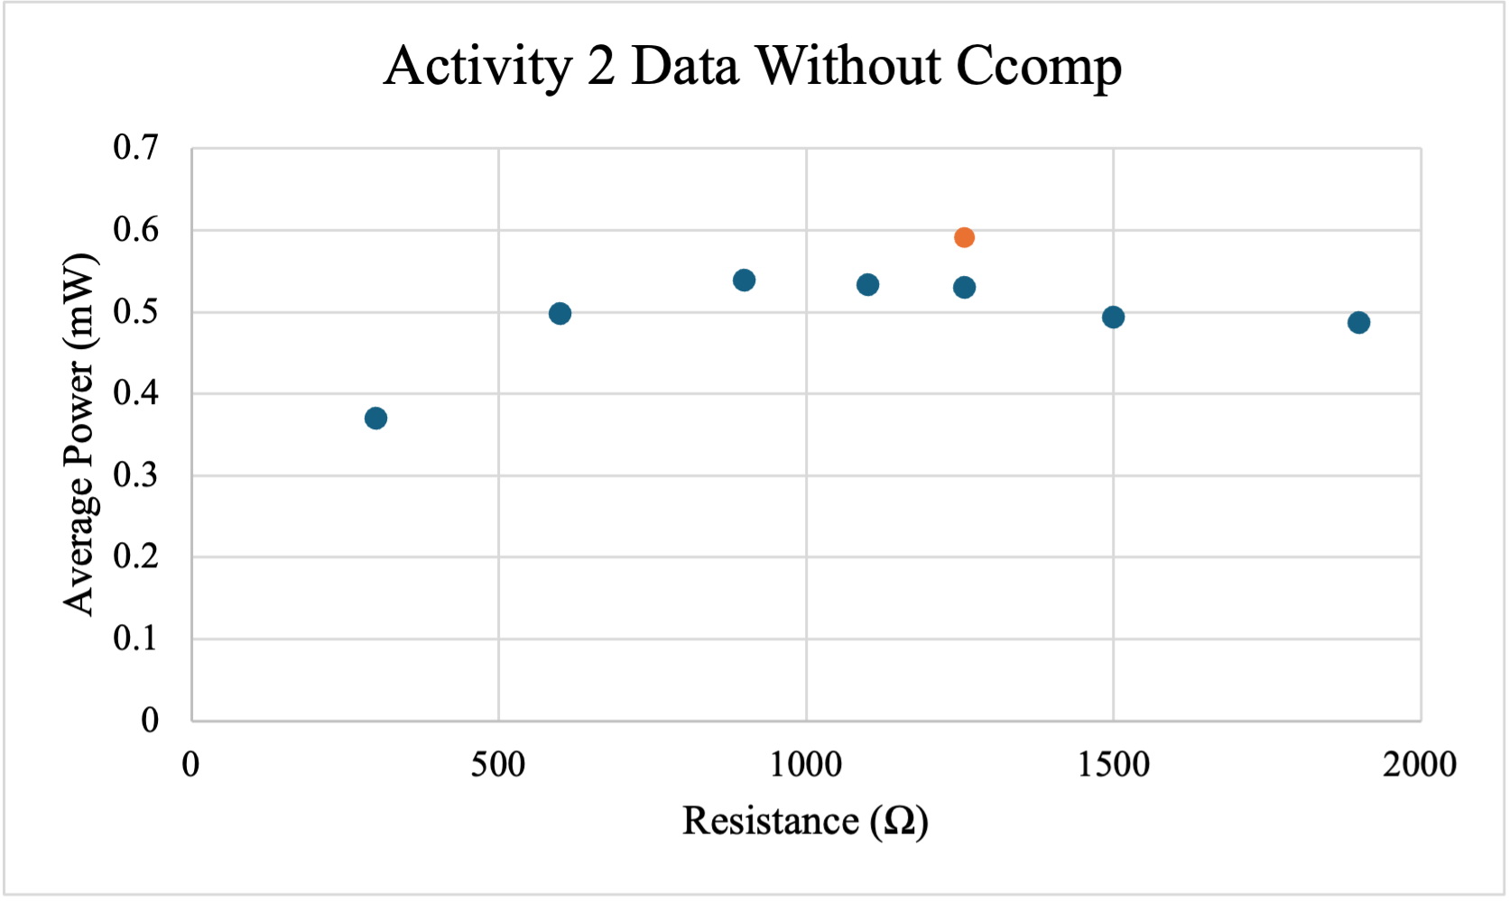

Fig. 11. The corresponding plot to Table IV. The orange point is the calculated value of the power. All other points are experimental.

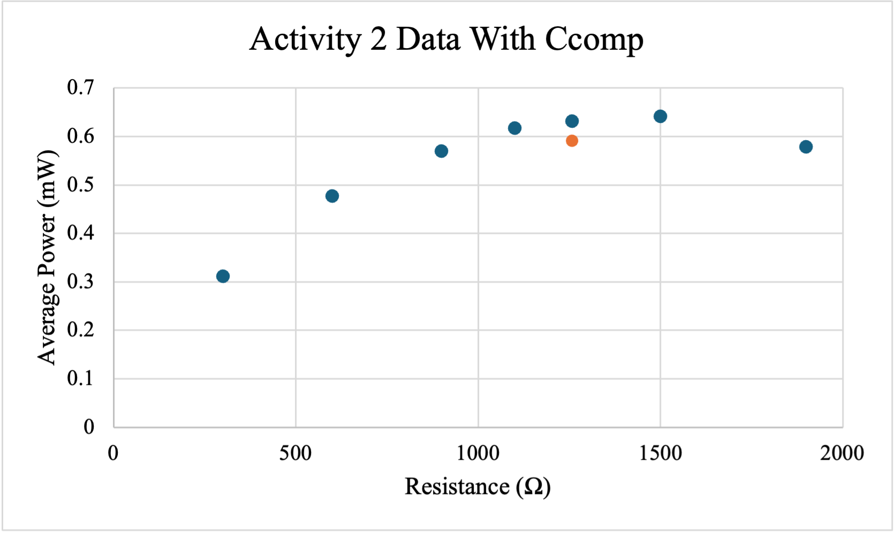

Fig. 12. The corresponding plot to Table V. Again, the orange point is the calculated and all other are experimental values.

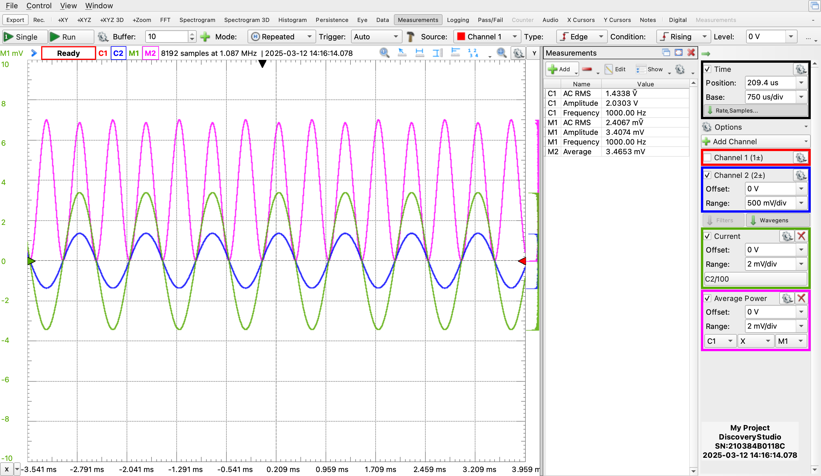

Fig. 11. The oscilloscope waveforms for $Z=R$.



Fig. 12. The waveforms for $Z=jωL$.

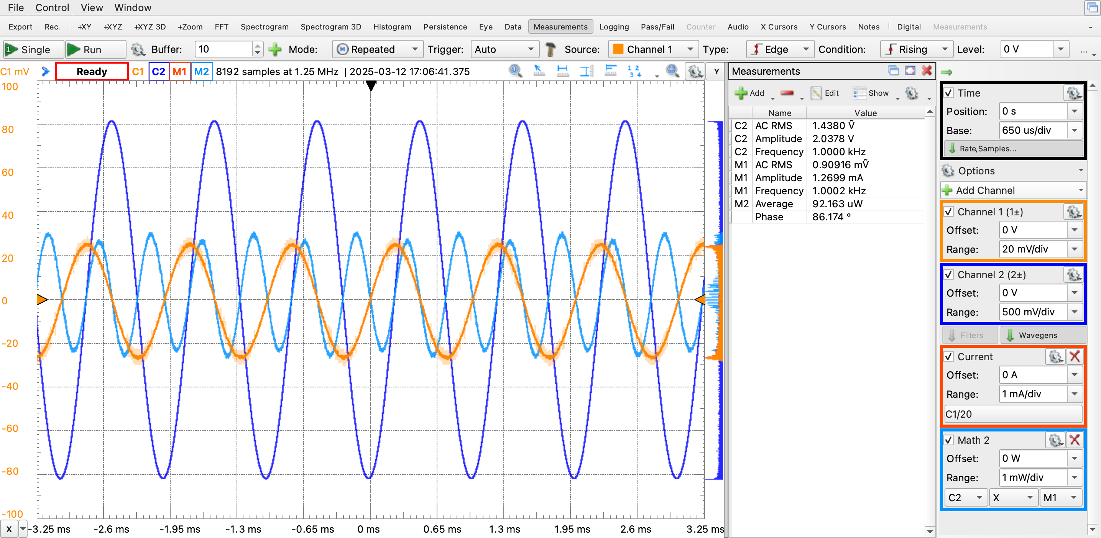

Fig. 13. The waveforms for $Z=1/jωC_{1}$

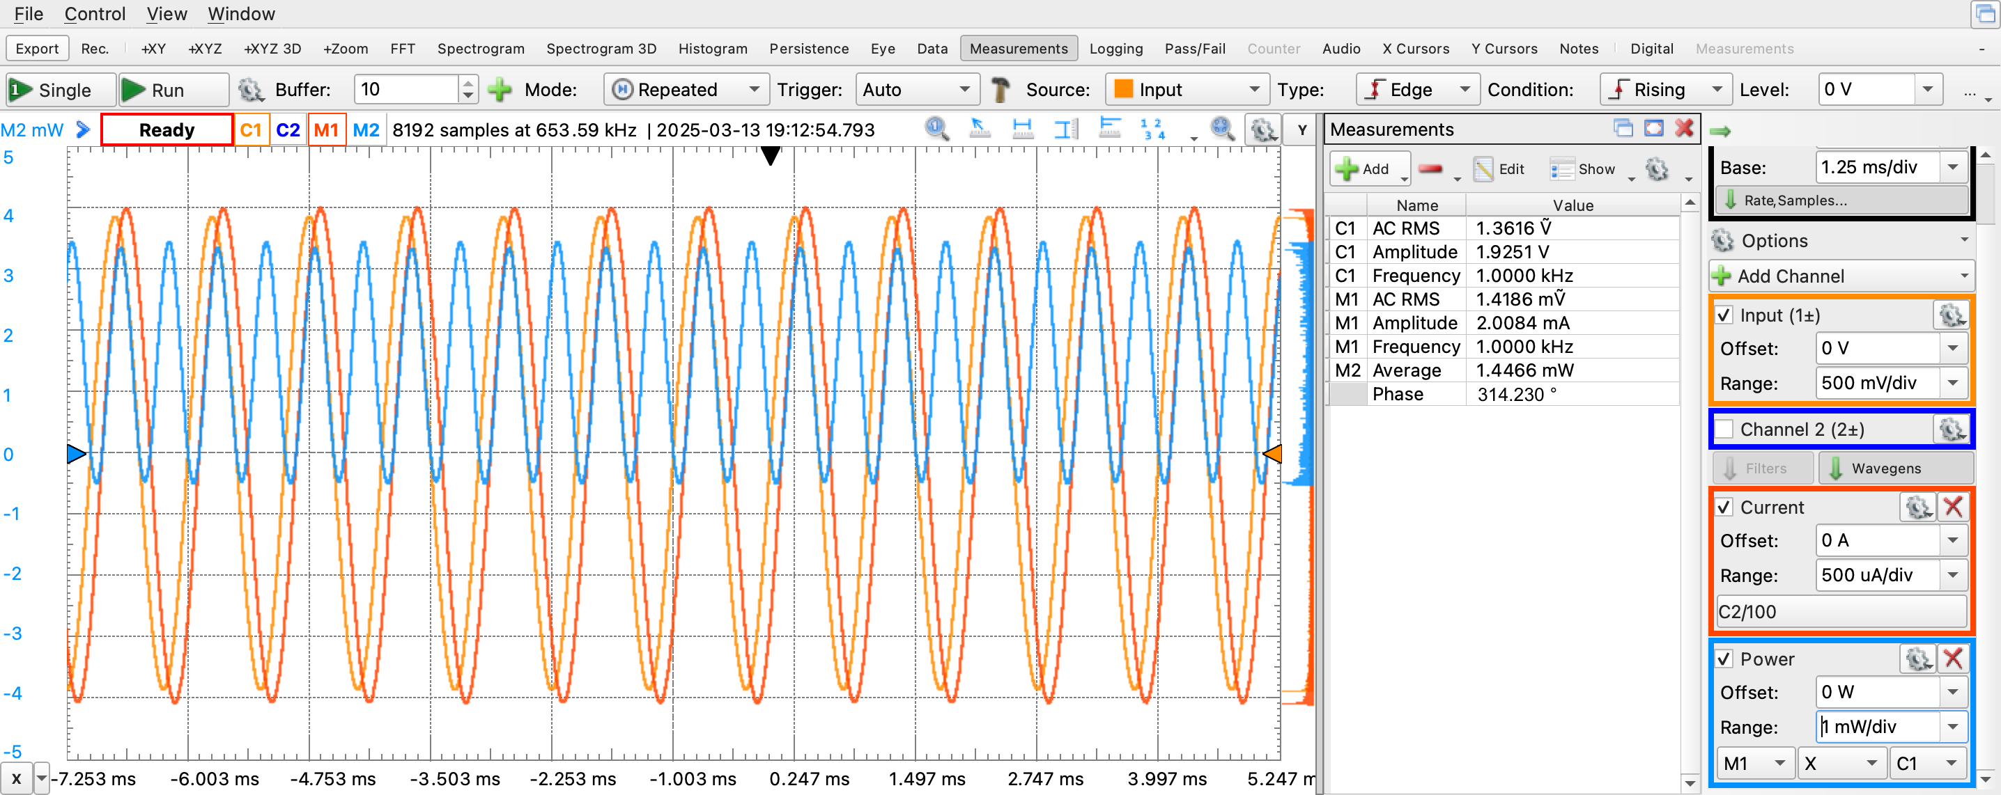

Fig. 14. The waveform for $Z=R+jωL.$

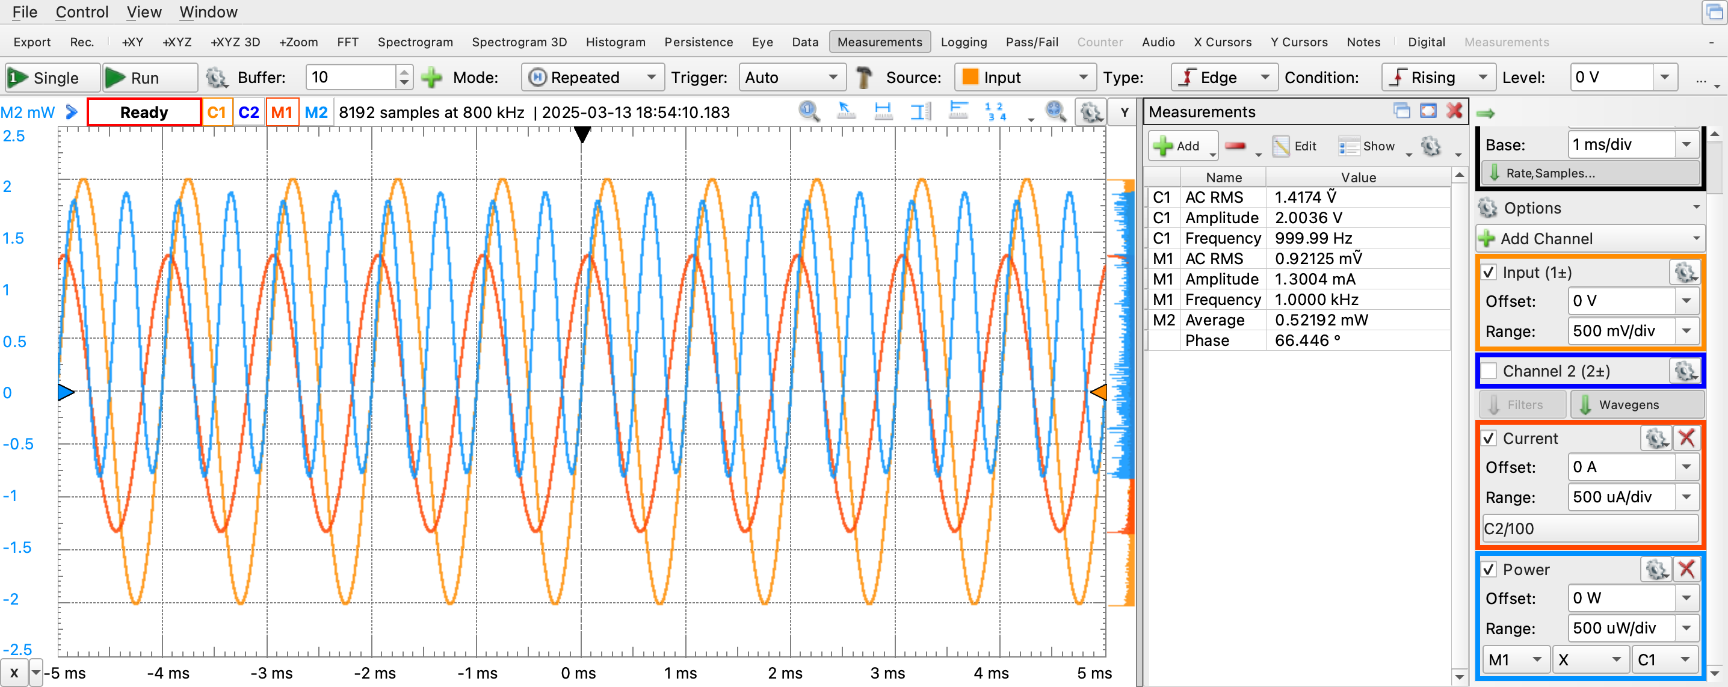

Fig. 15. The waveforms for $Z=R+1/jωC_{1}$.

1. LAB QUESTIONS
2. How do the signals in time relate to the phasor representation?

The signals in time relate to the phasor representations by magnitude and phase shifting. The magnitude of the phase angle is the RMS value of the signal in time. The angle of the phasor is the phase shifting of the signal in time.

1. Are there any discrepancies between theoretical calculations and experimental measurements? If so, explain possible causes.

Yes. There are slight differences between experimental and the theoretical values. The one main discrepancy is phase angle when $Z=-j1326 Ω$. It was expected to be -90, but the oscilloscope was reading 90. This could be an error on our part, but it would make more sense if it was 180° off, meaning the polarity of the leads were reversed.

1. What is the effect on the power transferred of increasing/decreasing the impedance of the  
   load?

The effect of changing the impedance will change the power across the load. The maximum power transfer will be somewhere between $0 Ω$ and $∞ Ω$.

1. What is expected if $R_{load}$ → ∞ or $R_{load}$ → 0? Explain your reasoning.

If the resistance is 0, then it will be a short circuit, and all the current will flow through the shot. If the resistance is infinite, then it will be an open circuit, and all the current will flow through compensation capacitor.

1. CONCLUSION

In activity 1 of our laboratory investigation, we examined the behavior of AC circuits under various impedances, focusing particularly on how time-domain signals correlate with their phasor representations. Through experimentation and analysis, we were able to visualize and quantify how changes in impedance from purely resistive through purely capacitive and inductive, to combinations of both, affect the AC circuit dynamics.

Our experiments clearly demonstrated that the time-domain signals of voltage and current are effectively represented by phasors. This phasor representation simplifies the complex sinusoidal behaviors observed in AC circuits, encapsulating both magnitude and phase information in a visually intuitive and analytically powerful format. For each impedance case, the phasor diagrams and power triangles constructed from experimental data aligned well with theoretical predictions, confirming that phasors are an indispensable tool for understanding AC circuit operations. The real-time waveforms provided insight into how voltage and current are affected by different types of impedance, with the phasor diagrams serving as a concise representation of these changes.

Activity 1 has provided us with valuable insights into the dynamic behavior of AC circuits under varied impedance conditions. The laboratory experience has reinforced the utility of phasor diagrams in simplifying complex waveforms. The findings from this activity not only enhance our understanding of theoretical concepts but also prepare us for more complex circuit analyses in future experiments.

Activity 2 proved to be difficult. The calculations were rather tedious, and having to learn how to impedance match outside of lecture was confusing. Once we were able to figure out the path, it proved to be rewarding. Another thing to note is that the expected maximum power did not happen at the calculated value, but rather at a higher value. This is likely because of the parasitic impedance of the inductor. This characteristic can also be attributed to why the average power was lower than expected.